**Client Registry Guidance**

**1.0 Scope:**

The Client Registry (CR) will store the patient’s demographic information. The information could be created, searched and updated in the CR. The CR should provide the functionality to merge and demerge the records. Each record in the CR will have a UUID. Depending on the weightages we provide for the matching and the threshold we had set, the CR should be able to perform the merging of records automatically. There should also be provision to do the merging and demerging manually as well.

Yet to decide on a platform for the Client Registry. Eg: OpenCR, SantéMPI Client Registry etc

The NEHR will store the clinical information about the patient. The data pertaining to the minimum dataset from each of the encounters will be pushed from the EMR to the NEHR. The NEHR could be accessed by the authorized people for View only purpose.

As of now, the CR is not available and it appears that it would not be available anytime soon. Thus, the HapiFhir server was configured to handle both the demographic and the clinical information.

**2.0 Patient Identity Workflows:**

Does the patient have a PHN?

Search in Local EMR

Yes

Register patient by generation a PHN

No

Is the PHN available?

Retrieve demographic data

Is the data correct in EMRt?

Check CR

Yes

No

Update the EMR and CR

Is the PHN available?

Yes

Register as a new patient by entering the PHN

Create in the CR

Yes

Yes

No

No

Is data tallying with the CR?

No

Yes

**3.0 Audit Workflow**

AuditEvent…

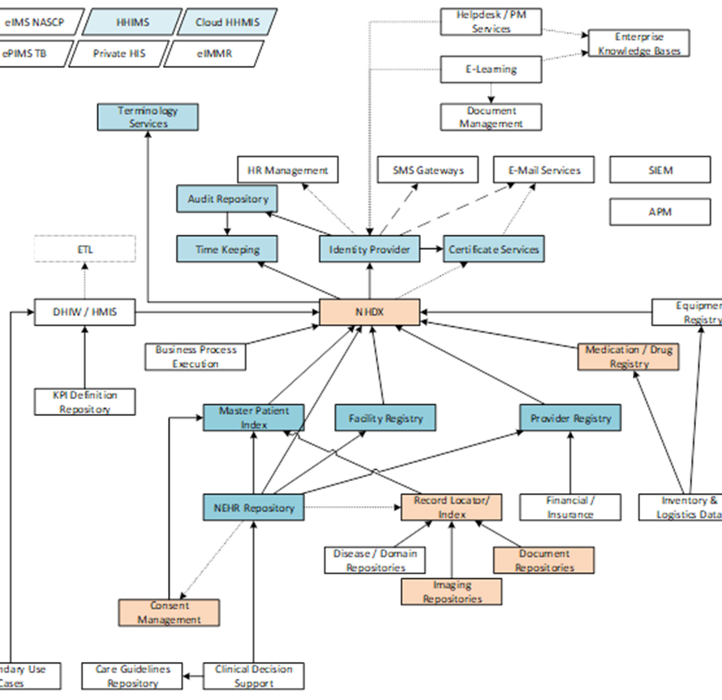

**4.0 Manage Acknowledgement**

OperationOutcome Resources:

OperationOutcome resources are collections of error, warning, and information messages that give thorough details on how a system attempt turned out.

Error messages …

**5.0 Security Protocols**

Whether to go with Key Cloak, API keys, 2-way LTS?

For the Diabetic Compass project, they are currently using Key Cloak to access the FHIR server. The vendors of CloudHIMS, HHIMS and OpenMRS also agreed to use the KeyCloak to access the server.

**6.0 Points Discussed regarding Patient data**

**6.1 Updating Demographic data**

If we find an error in the retrieved data from NEHR, it is not possible to update that encounter in the NEHR as the NEHR is accessed for View only purpose. But the corrected data should be entered into the EMR, and the record is pushed as a new encounter. However, if an error is found in the data retrieved from Client Registry, it can be updated. The FHIR server will store the new resource as the next version.

**6.2 Resource Identity**

There are two different ways to identify a resource:

1. By a "Location" URL that identifies where it can be accessed (based on the "Logical ID"). This location will be changed as it is copied/moved around.
2. By some inherent identifier ("Business Identifier" or "Canonical URL") that is part of the resource and remains fixed as it is copied/moved around. In SL Patient profile this refers to the slices of the Patient.identifier namely the PHN, NIC, PPN, DL, SCN, etc

Each resource has an id element which contains the "logical id" of the resource assigned by the server responsible for storing it. The logical id is unique within the space of all resources of the same type on the same server. Once assigned by the server, the id is never changed. When a resource is copied from one server to another server, the copy might or might not keep the same logical id on the new server. As there’s a possibility of shifting from one server to another at some point of time, it was decided not to store the logical id of the resource in the EMR, to avoid any confusions (Connectathon #2 Day 1) . However, there is a concern, when a particular resource cannot be uniquely identified by a particular business identifier (for example, when there are 2 separate records stored for a particular PHN), then storing the logical id within the EMR would become useful to identify the record accurately. (To be discussed further). Another option was also discussed, such as whether to store the logical id in the slice “other” under the identifier.

According to the SmileCDR (<https://smilecdr.com/docs/fhir_repository/resource_ids.html> ) the Resource ID, also known as the logical ID, could be assigned by the server or by the client.

Server assigned IDs are generated in 2 different modes:

1. SEQUENTIAL_NUMERIC (Default) - In this mode, each resource created on the server will receive a numeric ID assigned in sequence.
2. UUID - In this mode, each resource created on the server will receive a randomly generated UUID.

Client assigned IDs are generated in 3 different modes:

1. NONE - In this mode, clients may not assign a resource ID. Attempts to write to a resource ID that does not already exist will result in an HTTP 412 Precondition Failed.
2. ANY - In this mode, clients may assign IDs and there is no restriction on what these IDs may be, aside from the FHIR rules for valid resource IDs.
3. ALPHANUMERIC (Default) - In alphanumeric mode, clients may assign any ID except for purely numeric IDs

Following the discussion on Connectathon #2 Day 3, it was decided to change the server assigned ID Mode from SEQUENTIAL_NUMERIC to UUID and to keep Client generated ID in the default setting, which is ALPHANUMERIC. When the ID is assigned by the client, it was decided to use the UUID. Furthermore, if the ID is client generated the “PUT” action should be used instead of the “POST” in REST API to send the information to the server.

The Server assigned and Client assigned UUIDs to be stored in the EMR.

**6.3 Identifier**

Patient.identifier is made mandatory in the SL Patient profile and sliced into PHN, NIC, PPN, SCN, DL and other. (For further details please refer <https://lk-gov-health-hiu.github.io/fhir-ig/StructureDefinition-lk-core-patient-profile.html>

**6.3.1 PHN**

PHN is made mandatory in the SL Patient profile.

For a new patient (If patient/client doesn’t have a PHN), ideally a new PHN should be generated by the system. In certain systems, if the new PHN is entered by the user, we have to make sure at least the first 3 digits (the POI number) should be auto generated and also the check digit accordingly.

Validation rules to be added to the PHN when capturing.

In the systems that are using mobile apps, since there can be offline data entry, it is better to devise a way to pre-generate a certain number of PHNs beforehand.

As the cardinality of PHN is made 1..1 in the SL Patient profile, that is PHN is mandatory and also can hold a maximum of only 1 PHN for a particular patient instance, it is not possible to capture 2 PHN for a patient at the sametime, even if the patient is carrying 2 PHN with him/her.

**6.3.2 NIC**

The older NIC numbers have an alphabet at the end and which is case sensitive when trying to search, it has to be pushed to the CR in a uniform manner (?capital/ simple).

Validation rules to be added to the NIC number when capturing.

Also need to devise a way to search for the old and new NIC numbers

**6.3.3 PPN**

? we are not capturing the country that issued the PPN as of now in the SL Patient profile

**6.4 Name**

As the name is stored in different formats in the different EMRs (HHIMS captures as Name with initials. CloudHIMS captures as Name) it is suggested to map the captured names accordingly.

Eg:

First name to be mapped to Patient.name.given and if there is a middle name that also could be captured into the subsequent given name, that is to be mapped to Patient.name.given. (as the cardinality for Patient.name.given is 0..*).

Surname/ last name to be mapped to the Patient.name.family (cardinality for Patient.name.family is 0..1)

If the system captures the full name together or captures the name with initials together in a field, it should be mapped to Patient.name.text.

If the names are captured separately, after mapping to the relevant element, make sure to concatenate the names (eg; first name + last name) and map it to the Patient.name.text as well, so that it would facilitate the search process.

If a nickname is captured in the system, and if it is well known that its not the official name, the Patient.name.use could be specified as nickname, provided the system is capturing the use (eg usual | official | temp | nickname | anonymous | old | maiden)

(Please note that the name could be used as a search parameter and it would match any of the string fields in the HumanName, including family, given, prefix, suffix, suffix, and/or text)

(For further details please refer <https://hl7.org/fhir/R4/datatypes.html#HumanName> )

**6.5 Date of Birth**

In SL Patient profile the birthDate is made mandatory.

The date of birth to be mapped to the Patient.birthDate, which is of datatype date. A date, or partial date (e.g. just year or year + month) could be passed to the CR. The format is YYYY, YYYY-MM, or YYYY-MM-DD.

In case, the date of birth is not known, and the age is captured, it was decided to pass only the calculated year of birth and not the estimated date of birth, which is calculated from the current date based on the age (as decided on Connectathon #2, day 1).

As some systems are already calculating the date of birth when only the age is known, it was suggested to look into options, such as assigning only the year (when it is a calculated date of birth) to a new field (for eg. FHIR year) and pass it to the CR. This would facilitate storing only the actual date of birth in the CR and when only the age is known, it would store only the year.

**6.6 Organization Resource**

All the institutions, that is PMCU and above, will be registered under the Organization resource.

(LK Core Organisation Profile to be updated, to include the LK core address data type profile to the address).

The list of organizations to be included in the LK Core Organisation Profile will be taken from HIN list published by the Ministry of Health.

6.7 Location Resource

The hierarchy of the Administrative areas (Sri Lanka/Province/District/DS/GN) is not to be stored in the Location resource, as the Location resource can accommodate various other things such as clinics, wards, ambulances etc. Thus, the hierarchy should be contained only within the EMRs and not within the FHIR server. And the codes published in the SL FHIR IG for these administrative areas could be used.

**7.0 Vendor issues**

**(To be filled by the Vendors)**

|  |  |  |  |  |  |
| --- | --- | --- | --- | --- | --- |
| # | Issue | Use case | Vendor  (DC/HHIMS/CloudHIMS/ OpenMRS/ Swastha) | Outcome  (Resolved/Not Resolved) | Reference |
| 1 | MOH Area is not capture when Patient Registration | 2 | HHIMS |  |  |
| 2 | Both MOH and Address are not captured in OpenSRP | 2 & 3 | OpenSRP |  |  |
| 3 | DL is not capture when Patient Registration | 3 | HHIMS |  |  |
| 4 | Both DL and MOH Area are not captured in OpenMRS Cluster IS | 2 & 3 | OpenMRS |  |  |
| 5 | Better to have a standard for the title of the patient.  (which is mapped to Patient.name.prefix) |  | Suggested by HHIMS & OpenMRS |  |  |
|  |  |  |  |  |  |
|  |  |  |  |  |  |
|  |  |  |  |  |  |